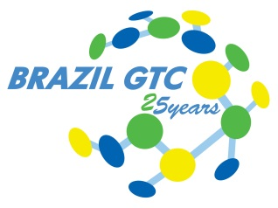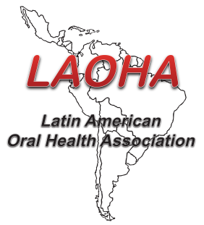**Special News**

**Demo Challenge 2nd edition**

It´s a great pleasure to share with you the 2018 Demo Challenge Program. This program is a collaboration between the Brazil Global Technology Center (GTC) and the Latin American Oral Health Association (LAOHA). In this second edition, we have accomplished a significant development in both the quality and the impact of the messages in our demos. Also, we have strengthened our collaboration among the different groups (GTC, MKT/CIC and LAOHA). Our new demos are providing a clear and compelling message, demonstrating the mode of action and benefits of our technologies. I would like to express my sincere gratitude to all teams that participated in this Demo edition.

*Abraham Cazes*

*Director of the Brazilian GTC*

**2018 Oral Care Challenge:**

The goal of the 2018 challenge was to create new DEMOs that visually explain the mode of action and benefits of our products. In partnership with CIC, Marketing, GTC and LAOHA four products were selected: **elmex Anticavity Toothpaste, Orthogard Mouthwash, Slim Soft Advanced Toothbrush and Sensitive Rapid Relief Toothpaste.**

In July, members of Brazil GTC assembled four teams. Each team had external support. This support consisted of a professor from LAOHA and selected members from Brazil Marketing and LATAM CIC organizations. Each team was assigned to a specific product and had to develop a video demonstration.

On November 1st, a panel of judges composed by Abraham Cazes, director of the GTC; Esi Seng, Marketing Director of CP Brasil;  Patricia Bella Costa, Director of Professional Relations; and Professor Magda Feres, vice president of LAOHA; evaluated each Demo based on communication, innovation and creativity. The winner of 2018 Demo Challenge was **elmex Anticavity Toothpaste** **team.**All participating teams received a gift and the winners were awarded with trophy and a celebration dinner. Runner up teams received a participation medal.

A major highlight of this program is the direct impact on the business, resulting in the fact that some Demos have been used for scientific and commercial communication. As example: our demos have been selected to be exhibit at the 2019 International Congress of Dentistry in São Paulo, CIOSP.

As for the experience, we value the opportunity to co-create and interact with the marketing teams, LAOHA professors and among our peers. Special thanks to our sponsors: Abraham Cazes and Bernal Stewart for supporting this program.

More to come,

*The Organizing Committee  
Bruna Souza, Enzo Utima, Paula Pantarotto, Paulo Focassio, Sandra Pereira and Zilson Malheiros*

Final Remarks

"We have received a new product in the Brazilian market, with the challenge of making consumers understand and embrace it. At first it was frightening," laughs Erico from elmex team. "We know that elmex has a differentiated technology and our DEMO has intended to pass this understanding on to anyone outside the company," he adds.

"It was amazing to see people's engagement and commitment in developing the DEMOs” says Enzo, activity leader from GTC. “There has been an evolution in all aspects and the connections we did with Marketing, CIC and LAOHA led us to understand our products in a different and broader perspective. We can't wait to start our next edition!" Zilson, activity leader from LAOHA remembers that the approach of creating a competition though a cross-functional team that would challenge and spark innovation is an initiative that could easily be done by other Colgate divisions or teams worldwide.

CSPR and Orthogard groups

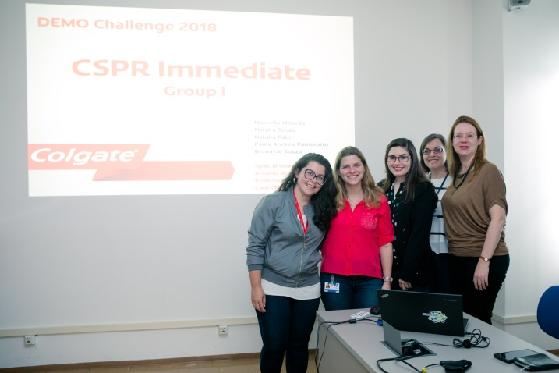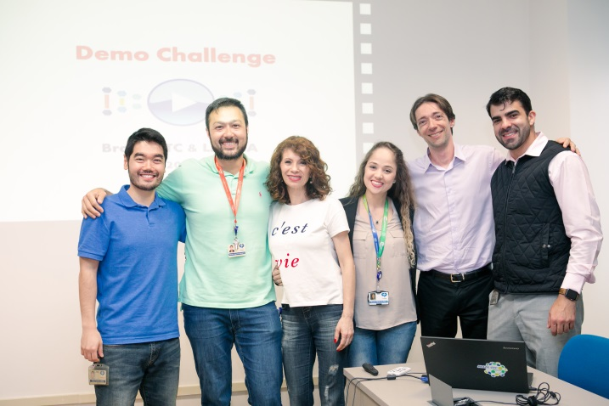

Slim Soft and Elmex groups

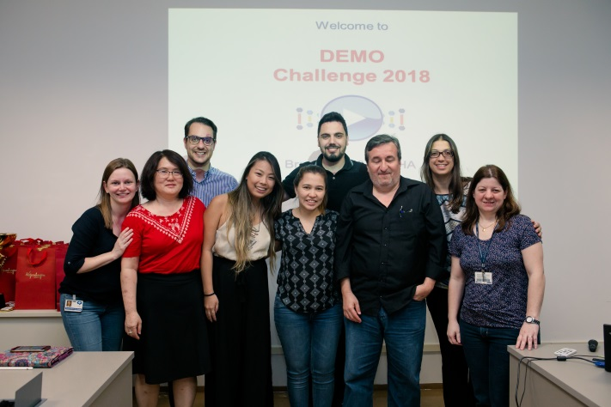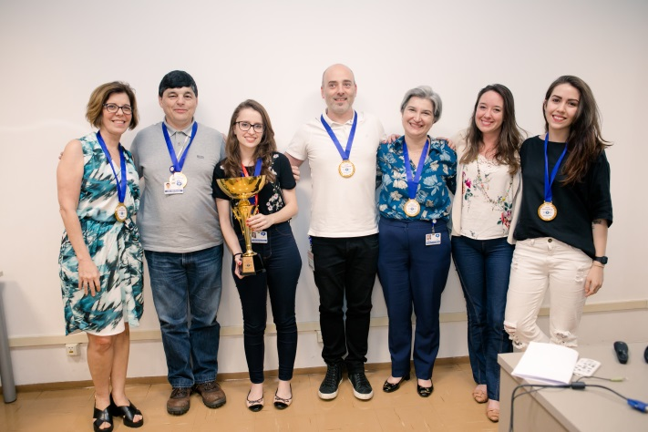

Participants and judge panel

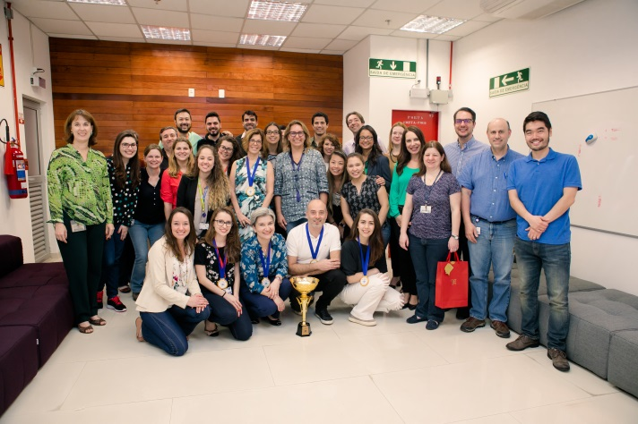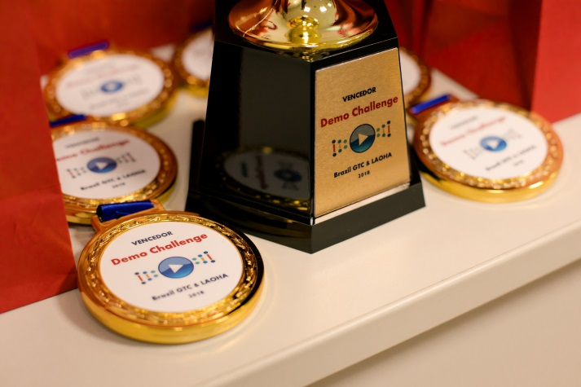

Legend to the photo groups:

elmex Anticavity Toothpaste Group (Winners): Abel Correia, Camilla Afonso, Érico Prat, Sandra Pereira, Professor Branca Vieira (LAOHA), Larissa Bueno and Isabel Gianesi (Marketing)

Orthogard Mouthwash Group: Enzo Utima, Isabel Batissaldo, Mayara Strini, Murilo Nakajima, Zilson Malheiros, Professor Claudio Pannuti (LAOHA) and Mariel Ginebra (CIC)

Slim Soft Advanced Toothbrush Group: Debora Pedroso, Luiz Alberto Gonçalves, Monica Santos, Paulo Focassio, Raquel Margutti, Professor Juliano Cavagni (LAOHA) and Flavia Liberman (Marketing)

Sensitive Rapid Relief Toothpaste Group: Bruna Souza, Marcella Mourão, Natalia Fabri, Natalia Souza, Paula Pantarotto, Professor Luciene Figueiredo (LAOHA) and Alejandra Alanis (CIC)